Participant’s name: NORZAIDI BAHARUDIN

Lesson Plan

Title of Lesson: | Building a Functional Retrieval-Augmented Generation (RAG) System Using Open WebUI
Unit / Program: | AI Awareness Program
Target Audience: | Special Branch Desk Officer
Date Lesson Plan was created or last updated: | 27 November 2025
Lesson Plan version number: | 1.0
Length of Lesson (in hours): | 1 hour
Instructional Designer(s): | Norzaidi Baharudin
Contributing Subject Matter Experts (SMEs): | Azam Aidid Abd Rahman
Instructional Strategies/Methods: | Lecture; Q&A; Story Telling, Online Quiz; Demos; Personal reflection
Copyright Information∗: | No copyrighted materials were used in the creation of this lesson
Prerequisite Blocks of Instruction: | Nil, but participants should have a good working level of English
Prerequisite Online Training (if any): | Nil
Additional Information: | Nil
Reviewed and Approved by: | Khairul Akmam Ibrahim
Date of Approval: | TBC

Goals and Objectives

Instructional Goal:
Using the Open WebUI interface, participants will implement a functional RAG system capable of retrieving relevant context from uploaded documents to accurately answer user queries.

Learning Objective(s):
After 1 hour of instruction, the student will be able to:

- Given access to the live Open WebUI environment, participants will list at least three main features of the interface and explain the basic components of a RAG system, as demonstrated during a guided walkthrough.
- Using the live Open WebUI interface, participants will configure the essential components of a basic RAG pipeline (e.g., document collection, embedding settings, query module), successfully saving and running the configuration as verified by the instructor.
- After uploading example documents in the Open WebUI, participants will verify and demonstrate that each file has been correctly assigned to the correct collection and that embeddings are successfully generated, as shown in the interface status/logs.
- Given one or more user queries, participants will evaluate the accuracy and relevance of answers generated by the RAG system in Open WebUI, and report on whether the retrieved context aligns with the queries, achieving at least 80% correct identification as measured by an instructor-provided answer key.

Assessment (Questions & Answers)

One question & ONE ANSWER for each Learning objective

- Given access to the live Open WebUI environment, participants will list at least three main features of the interface and explain the basic components of a RAG system, as demonstrated during a guided walkthrough.
- Model Selection
- Workspace
- Search
- Using the live Open WebUI interface, participants will configure the essential components of a basic RAG pipeline (e.g., document collection, embedding settings, query module), successfully saving and running the configuration as verified by the instructor.
To configure a basic RAG pipeline in Open WebUI, participants first create or select a document collection, then choose an embedding model and enable retrieval for that collection. Next, they link the collection to the chat or RAG workflow so that queries use the selected collection as a context source. Finally, they save the configuration and run a test query to verify that relevant context is retrieved from the uploaded documents.

- How can you verify within Open WebUI that uploaded documents have been correctly assigned and embedded into a specific collection?
Participants can open the target collection and check that each uploaded file appears in the document list for that collection. They then review the embedding or processing status indicators or logs to ensure each document shows as successfully embedded or indexed. If all files are present and marked as completed, the ingestion and embedding process is confirmed.
- Given one or more user queries, participants will evaluate the accuracy and relevance of answers generated by the RAG system in Open WebUI, and report on whether the retrieved context aligns with the queries, achieving at least 80% correct identification as measured by an instructor-provided answer key.
Participants can compare the answer to the original query to check that it directly addresses the user’s question without adding unrelated information. They also inspect the retrieved context passages to see whether the answer is supported by those documents and whether key facts match the source content. If the majority of answers (for example, at least 80%) are both factually correct and clearly grounded in the retrieved context, the RAG system is performing to the desired standard.

Equipment and Materials

Equipment / Aids Required for Instructor:
- Computer with PPT software / Canva and screen
- Canva SaaS
- Projector or big screen
- Flipchart or whiteboard
- Colored markers in various colors
- Internet Connection

Equipment / Aids Required for Participants:
- Pens or pencils for taking notes
- Smartphone or computers for online quiz and hands-on
- Internet Connection

Handouts (listed in the order they are distributed):
- Slide QR Code

Outline of Activities
The content and instructional activities must be described in sufficient detail to ensure consistent delivery of instruction by different instructors. All content—and only content—is presented in the left-hand column. All other information including PowerPoint slides, the setup of activities (procedures, time limits, outcomes, etc.), etc. is presented in the right-hand column.

Content | Instructor Notes / Description of Activities
Grabber 1:  I’m honoured to be the first person presenting a 20-minute instruction today. And with a bit of fun, I’m happy to introduce you to my AI “girlfriend” — she’s here to capture your attention and guide you into the session you’re about to hear.  Grabber 2:  You’ve probably noticed I’m wearing Meta Ray-Ban glasses. These glasses can act as a direct link to your AI and your own RAG system. Imagine meeting your boss and suddenly he asks a question you don’t know. Instead of panicking, you quietly ask your AI through the glasses, and it gives you the exact answer instantly. That’s the power of personal GenAI with RAG. | Timing : 3 min  Method of instruction: Video Clip Generated with AI, Demo Meta Rayban  Suzy AI will introduce my self with 1 minute simple introduction from her.  
Introduction:  - Before we talk about RAG, we need to understand how AI has changed over time  - The “AI” discussed in the 1950s was rule-based — systems that followed fixed instructions and could not learn or create anything new.  - Today’s AI is Generative AI, which can produce new content such as text, images, audio, and video.  - Generative AI works because of Large Language Models (LLMs) the “brain” that understands language, reasons, and generates responses.  - Popular LLMs include GPT-5.1 (OpenAI), Gemini 2.5 Pro, Claude, Copilot, and many open-source models like Llama.  - Modern AI is no longer about simple automation; it is about intelligent content generation.  - This is why we need RAG a method that combines our private or updated knowledge with LLMs to avoid hallucinations and produce accurate, domain-specific answers.  Self-introduction:  I am DSP Ts. Norzaidi Baharudin, a Special Branch (SB) officer, and I have served in the SB since 2007. I am from Malaysia and currently stationed at the Royal Malaysia Police Headquarters, Bukit Aman as SME in IT and Cyber Security.  Beyond law enforcement, I am actively involved in both industry and academia. I am a certified Malaysian Qualifications Agency (MQA) Trainer and an Assessor with the Technology & Technical Accreditation Council (TTAC) under the Malaysia Board of Technologies (MBOT). Both MQA and MBOT are national bodies responsible for certifying and accrediting higher education institutions and technical programmes in Malaysia. | Timing: 7 min  Method of instruction: Lecture  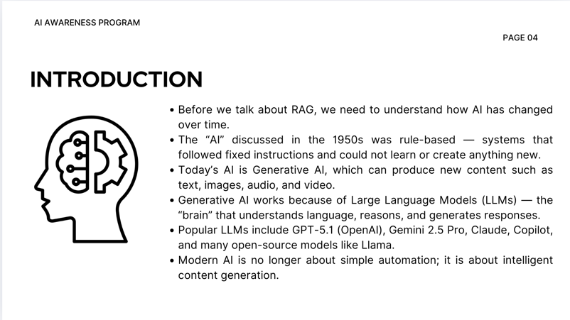
What is RAG:  - Please scan the QR code and answer the slido.  - In simple terms, RAG is a GenAI system that carries your own knowledge.  - Yes, today’s GenAI tools like ChatGPT, Gemini, and Copilot are incredibly intelligent and can answer almost anything. But when we ask about our own research or our specific working domain, they may hallucinate and produce ridiculous answers. So, as Suzy mentioned earlier, RAG lets you build your own GenAI model powered by your own data — giving accurate, context-specific answers. | Timing : 5 minutes  Method of instruction: Open question using slido  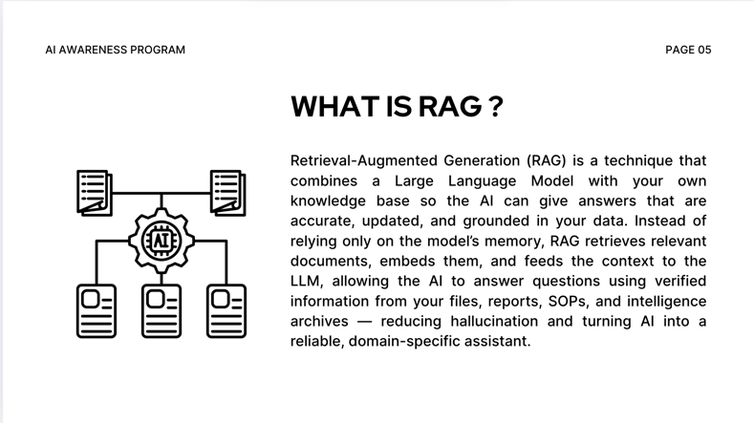    https://app.sli.do/event/7MtwWrYMSyErApnUqGaa23  or  https://neo.matnet.my/slido
Connection of Content to Job Roles & Responsibilities:  Knowledge Continuity  RAG preserves operational knowledge so it stays in the unit even when officers retire, transfer, or change roles.  Rapid Intelligence Retrieval  Officers can quickly access past reports, case notes, and SOPs through an AI chatbot instead of manual searching.  Better Decision-Making  LLM + RAG provides accurate, up-to-date insights, helping officers make faster and more confident operational decisions.  Enhanced Intelligence Analysis  AI assists in extracting patterns and insights from large datasets such as OSINT, digital forensics, chat logs, and PDFs.  Higher Productivity & Efficiency  Automation of routine tasks (summaries, drafting, documentation) frees officers to focus on core investigative and analytical work. | Timing – 10 min  WIIFM (What Is In It For Me?)  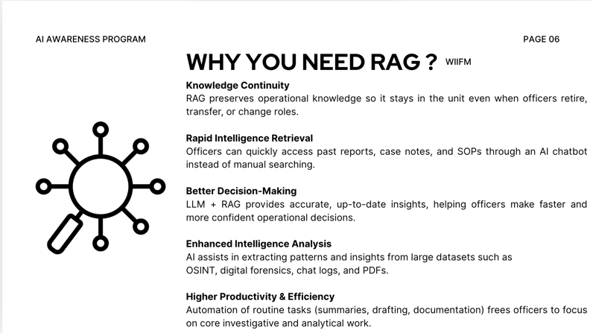
Learning Objective #1:  List three main features of the interface and explain the basic components of a RAG system.  1A – RAG meaning :  Retrieval-Augmented Generation (RAG) is a technique that combines a Large Language Model with your own knowledge base so the AI can give answers that are accurate, updated, and grounded in your data. Instead of relying only on the model’s memory, RAG retrieves relevant documents, embeds them, and feeds the context to the LLM, allowing the AI to answer questions using verified information from your files, reports, SOPs, and intelligence archives — reducing hallucination and turning AI into a reliable, domain-specific assistant.  Main features: Workspace, Model Selection, Search  RAG features: Model Selection, Create Knowledge Base, Create new Model.  1B – Quick Survey  How do you feel about the UI or layout of Open WebUI ? | Timing – 10 min  Method of instruction: Lecture, Quick Quiz and Survey  1A - The interface  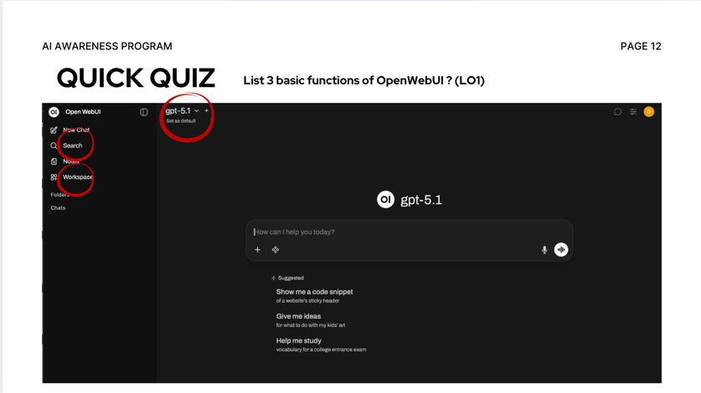  1B – Get the participant to first reaction of the Open Web UI interface. Does it user friendly or complicated ?  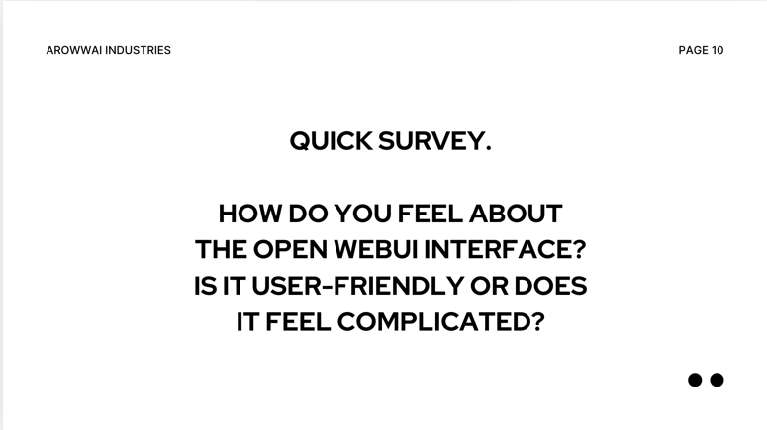
Learning Objective #2:  Participants will use the live Open WebUI interface to set up a basic RAG pipeline — including collections, embeddings, and query settings — and successfully save and run the configuration as confirmed by the instructor.  2A – Step to produce  Step to setup Knowledge Base:  1 – Login with your credentials  2 – Click on Workspace  3 – Click on Knowledge Tab  4 – Click + sign on the right side of the screen  5 – Create new Knowledge Base  6 – Fill in Knowledge Base name, basic instruction, and visibility access of your knowledge.  7 – uploading sample documents to your RAG  Step to setup model + knowledge base:  1 – Click on Model tab  2 – Click + sign n the right side of the screen  3 – Fill in the information about your model. The most crucial element you need to fill in is your selection model of LLM and the knowledge base you created before.  2B – Q&A  What is the best model you should use on your knowledge base ? | Timing – 10 min  Method of instruction: Lecture, Demo, Video and Q&A  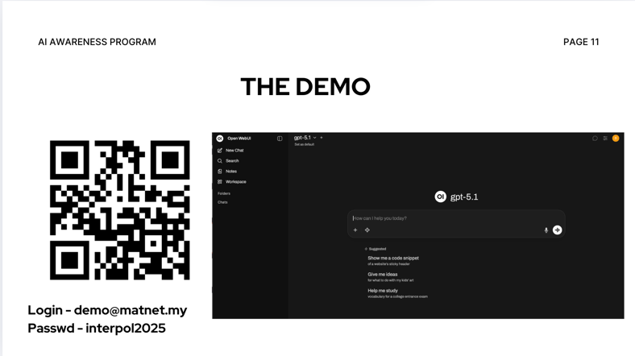  2A  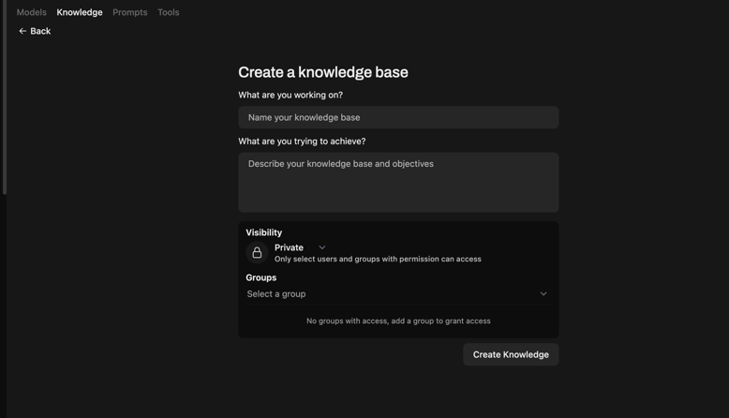  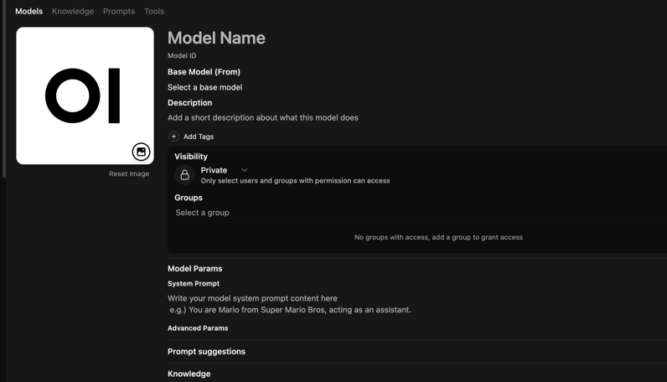  2B - Q&A  Collect ideas from the participants on which model is the best ?
Learning Objective #3:  After uploading example documents in the Open WebUI, participants will verify and demonstrate that each file has been correctly assigned to the correct collection and that embeddings are successfully generated, as shown in the interface status/logs.  Step to verify:  1 – Click on Name of the Knowledge Base  2 – You will see the collection of files uploaded in Search Collection | Timing – 5 min  Method of instruction: Lecture, Demo, Video  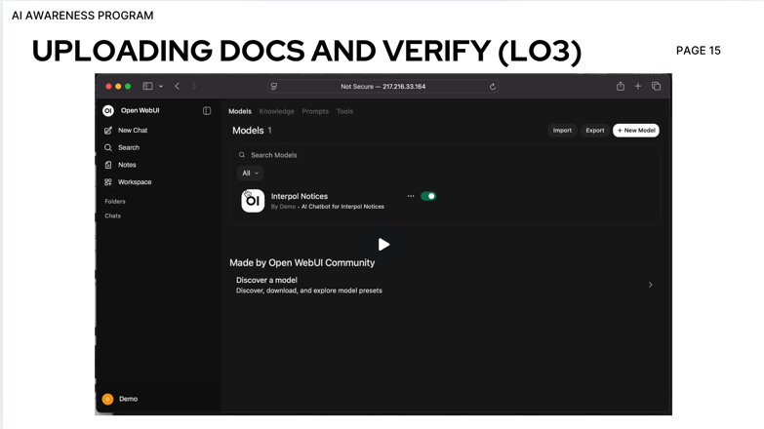  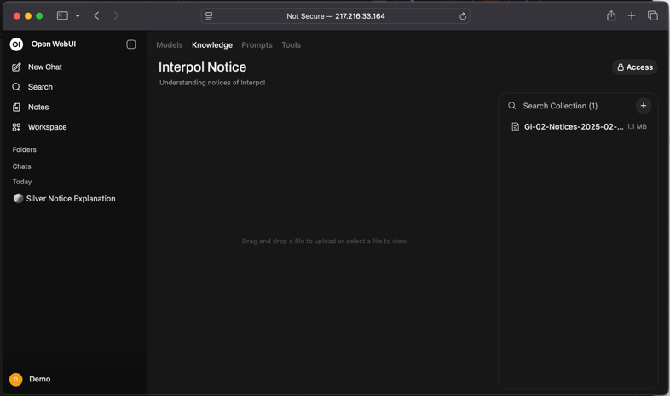
Learning Objective #4:  Participants will evaluate the accuracy and relevance of answers generated by the RAG system in Open WebUI, and report on whether the retrieved context aligns with the queries, achieving at least 80% correct identification as measured by an instructor-provided answer key.  4A - Step to evaluate / testing:  1 – Click on model tab  2 – Select model that have you been created before  3 – Start Chat with your data  4B – Test the system by asking questions about the documents you uploaded to the RAG. Evaluate whether the answers are correct, relevant, or out of context.  - Participants must complete 5 queries. If at least 4 out of 5 answers match the answer key and are contextually appropriate, the acceptance criterion (80% accuracy) is met. | Timing – 5 min  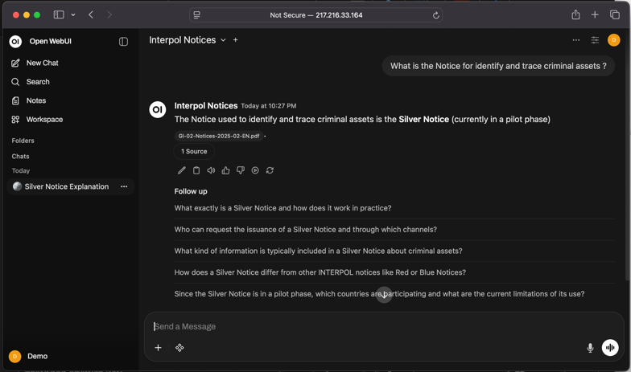
Summary/Conclusion:  - Today’s AI is powered by LLMs and becomes truly useful when combined with our own knowledge through RAG.  - RAG solves the problem of lost expertise, fragmented documents, and inconsistent information in daily operations.  - Tools like Open WebUI allow us to build secure, private, and domain-specific AI assistants using our internal data.  - With proper setup collections, embeddings, vector databases, and queries officers can retrieve accurate, up-to-date intelligence instantly.  - Integrating RAG into our workflow improves decision-making, productivity, and knowledge continuity across the organization. | Timing – 5 min

References
[1] Lewis, P., Perez, E., Piktus, A., et al. (2020). Retrieval-Augmented Generation for Knowledge-Intensive NLP Tasks. Advances in Neural Information Processing Systems, 33, 9459–9474.
[2] OpenAI. (2023). GPT-4 Technical Report. Retrieved from https://arxiv.org/abs/2303.08774
[3] Open WebUI Documentation. (2024). Installation and Configuration Guide. Retrieved from https://openwebui.com
[4] Brown, T. B., Mann, B., Ryder, N., et al. (2020). Language Models are Few-Shot Learners. Advances in Neural Information Processing Systems, 33, 1877–1901.
[5] Karpukhin, V., Oguz, B., Min, S., et al. (2020). Dense Passage Retrieval for Open-Domain Question Answering. Proceedings of the 2020 Conference on Empirical Methods in Natural Language Processing, 6837–6851.

List Slides and Handouts
CANVA SLIDES (LISTED BY TITLE):
- Building a Functional Retrieval-Augmented Generation System
- Goals & Objective
- Introduction
- What is RAG?
- Why You Need RAG? WIIFM Knowledge Continuity
- AI Tools (Local PC/Server Installation)
- The Demo (Login Information)
- The Demo (Sign In to Open WebUI)
- Quick Survey: How do you feel about the Open WebUI Interface?
- The Demo (Open WebUI Interface Overview)
- Quick Quiz: List 3 Basic Functions of OpenWebUI (LO1)
- Create Knowledge Base (LO2)
- Create Model (LO2)
- Uploading Docs and Verify (LO3)
- Evaluate Chatbot Answer (LO4)
- Summary
- Thank You

HANDOUTS & TRAINING AID:

- QR Code – Canva Slide Link
- QR Code – Slido Q&A
- QR Code – Demo to RAG System URL
- Meta Rayban Glasses – AI Gadget for RAG Demo

∗ Copyright information is required. If no copyright permissions are needed, please insert the applicable statement in this blank, either “No copyrighted materials were used in the creation of this lesson,” or “Use of copyrighted materials is in compliance with fair use guidelines.” If copyright permission has been granted, please attach all documentation and maintain it on file.

